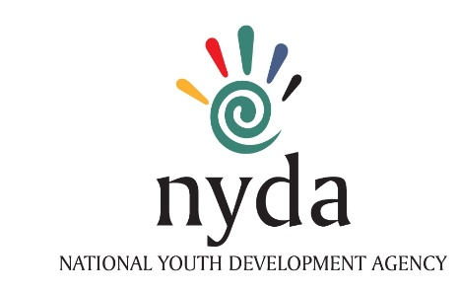
MP-AF-02

MENTOR - APPLICATION FORM

PERSONAL DETAILS
Mr. / Mrs. / Ms. / Dr. / Prof. / Sir

Surname

First Names
Date of Birth
Street Address
Postal Address
City/ suburb / Village
Municipality
Province
E-mail
Work Phone No.
Mobile Phone No.
Preferred Contact No.
Business Name
Qualification(s) Obtained
Company / Institution
Are you a professional/business owner/ employee
No. of years of experience in business
Criminal Record
No. of years involved as a mentor
Name other Institutions involved as a mentor
Years of mentoring experience and area of mentoring

Give your ideal profile of the mentee you would like to be matched or paired with.

SKILLS & EXPEREINCE

Provide details of the Business Skills that you must support the NYDA – VBMP:

Please provide a short profile explaining the mentoring/services that you previously provided to young entrepreneurs/ or would like to provide to young people and the value it added to their businesses/ or will intend to have.

State what you hope to benefit from the programme as a Mentor.

SECTORS & BUSINESS TYPES:

Tick all relevant sectors and business types that apply to your skills and experience areas where your strengths and double tick those that are strongly developed

Retail / Wholesale Service Manufacturing Franchising
Agriculture,  Arts & Entertainment  Building & Construction  Business Services  Chemical & Pharmaceutical  Electrical & Electronics  Fashion & Clothing  Food & Beverages  Information Technology  Paper & Printing | Pottery & Glassware  Restaurant & Fast Foods  Textiles & Soft Furnishing  Timber & Wood  Tourism & Hospitality  Vehicle Repairs & Parts  Water  Other 1 ________________________________  Other 2 ________________________________  Other 3 ________________________________

Terms and Conditions:

- The Business Mentorship Programme is implemented through the support of volunteer Mentors
- Mentees are recruited and assessed by the Branches of the NYDA
- Mentees are matched with mentors based on the assessment
- Only NYDA – Mentorship Programme contracted mentors should render mentoring support to mentees

Indicate the name of the NYDA Branch/ Branches that you would like to service as a mentor:
____________________________________ _______________________________
____________________________________ _______________________________

Thank you for your interest in applying to be a mentor and for completing this form.

Please note that Mentors are required to sign a Memorandum of Understanding which outlines the terms of their engagement in the programme prior to any service rendering.

Signed: __________________________________________ Date: _____________________
(Applicant)

- Please attach copy of your CV for vetting

- Mentor applications and supporting documents must be submitted to the nearest NYDA office/branch.

